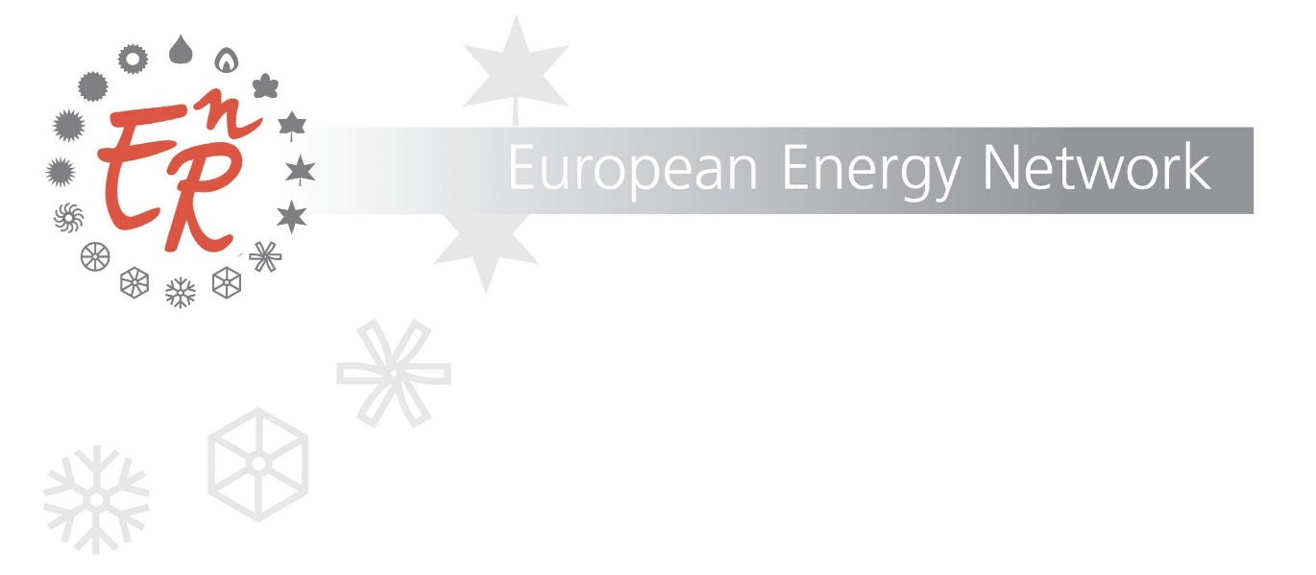

30th October 2020
E^{n}R Thinking Group Meeting Meeting Minutes

Online meeting via Webex
Chaired by Barto Piersma, RVO, the Netherlands

Participants: Kerstin & Leonardo (Coordinator CA RES), AEA, Austria, Tsveti & Ognian, SEDA, Bulgaria, Irmeil, Motiva, Finland, Irina, Ademe, France, Vasilis, Charalampos, CRES, Greece, Helen, SEAI, Ireland, Roberta, Alessandro, Enrico, Enea, Italy, Charles, Manuel, EWA, Malta, Barto, Bert, Marian, Rebecca, Wiesje, Jacques, Marion, RVO & Frank (Consultant), the Netherlands, Luis, Rui, Adene, Portugal, Stanislas, SIEA, Slovakia, Virginia, Marisa, Miguel, IDEA, Spain, Josephine, STEM, Sweden, Anil, DEEE, Turkey, Philip, Emilie, Katie, Colin, EST, UK
Item | Description | Responsible
1 | Welcome & Opening  Barto welcomed all participants to the meeting. It was noted that almost all member agencies were represented.  Agenda M66 adopted. | Barto
2. | Introduction Smart Sector Integration  Marian briefly introduced the subject – a means not a goal.  The Task Force continues to support the analysis work of Frank and Jacques. Many inspiring examples of smart sector integration have been identified and Frank and Jacques are now delving deeper into the projects, looking at how they were implemented, what role the agencies played etc. through a series of interviews with technical and policy experts on the topic. It is evident that the Commission is interested in this topic and that it should be inclusive/ just.  At the Regular meeting held in June Bert talked about the different levels of smart integration – international, national, local. Jacques zoomed in on the local involvement, highlighting the obstacles and possible solutions and roles for the energy agencies – bridging the gap between policy and practice.  All participants were asked prior to the meeting in which break-out group they would like to participate. The groups will be led by Jacques, Frank and Marion Bakker – new to this network. She is an expert in Smart sector integration, and will focus on the consumer and policy engagement side. Marian then invited Frank to provide a short update on the interviews followed by short pitches on each of the case studies. | Marian
3. | Pitches – 3 Case Studies:  - Smart Building-integrated PV Systems  - Smart Integration of Renewables and vehicle charging  - Consumer and policy engagement – win-win?  What intermediary role could energy agencies play?  Before splitting into break-out sessions on the 3 topics mentioned above, Frank gave a brief update. He explained that he had started with the interviews, but that it had proven more difficult than first anticipated to identify the right persons to interview. Most interviews will be held during the month of November, with the aim to get as many results as possible in time for the Round Table event with the Commission on 25th November.  So far we have received a great variety of inspirational examples (taken also from the homework carried out prior to the meeting in June and the Factsheets), which makes it difficult to analyse.  Frank mentioned the challenge to find markets to give a voice to technical opportunities and the challenge of innovation and new concepts versus regulation which can be a hindrance to smart integration.  Jacques, Frank and Marion each gave a short pitch on their respective case study. Please refer to the presentations.  Philip queried whether Jacques would cover the cooperative movement (i.e. cooperate and share benefits). Jacques confirmed that he would cover this. | Jacques  Frank  Marion
4. | Brainstorm in break-out sessions  Please refer to the attached summaries of the break-out sessions.
5. | Report back finding and reflections on discussions during the break-out sessions  Each group provided a short summary of the outcomes of their discussions.  Bert then provide some reflections and lessons learnt  Opportunities & Role of Agencies  Observations  - Key role of agencies to bridge the gaps  - between individual and collective interests – consequences on how instruments are designed and implemented. Formal like municipalities or energy collectives;  - individuals v companies and market players – how they interact;  - policies v drivers;  - interaction between sectors  - How can we do this  - Need portfolio of examples what role do energy agencies play? Differs per country  - Almost all have the three roles on common:  - provide financial advice and subsidies;  - convening power;  - advisory role towards ministries and regulators.
6. | Round Table EnR & EC on Smart Integration, Renovation Wave and Just Transition  Rebecca referred to the draft outline for the Round Table circulated prior to the meeting and summarised the discussion she had had with Karlis Goldstein regarding the event.  Date: 25th November 10.30 – 12.00  A discussion took place on whether to invite other DGs. It was agreed that we should not invite too many DGs, we should not have too broader reach. Following the Task Force meeting on Smart Integration, Roberta had already suggested that we contact DG REFORM. Karlis already provided a contact and invited DG REFORM to the event. Rebecca to plan in an introductory meeting with Kaspar Richter.  It was agreed that Cohesion funds are important in support and finance for achieving the goals of the Green Deal. Karlis had suggested that we contact Wioletta Dunin (Cabinet Fereira) who is an expert on Cohesion and has an excellent knowledge on energy.  Virginia offered to look into a contact for DG ENV.  16th November Troika plus meeting 10.30 – 12.00 (CET) to prepare the Round Table in more detail.  European Investment Bank (EIB)  Karlis put us in contact with the EIB with Ralf Goldman.  Rebecca had an introductory meeting with Dinis Rodrigues who knows many EnR members. Rebecca shared the Infographic and spreadsheet containing a selection of best practice examples and explained briefly about the Round Table.  Ralf and Dinis have agreed to participate in the Round Table.  We will also have an extra meeting between the Troika plus and the EIB immediately preceding the Round Table at 9.30 – 10.30 (CET) on 25th November. | Rebecca  Rebecca  Virginia
7 | Wrap-up and Closing  Barto thanked all participants for their input into the inspiring discussions held. He hopes to be able to hand over the hammer to Philippe in person on February.  Confirmation of date of the Full meeting  17th & 18th February either in the Netherlands or online. | Barto

